Calendar Year End Procedure in PDS Ledger
Last Updated: January 2024

Important Notes:
- Obtain vendor calendar YTD totals BEFORE closing the month of December. This is very important because the Year End Procedure deletes the calendar YTD totals automatically when December is closed. You may continue to post activity to the month of January, including printing checks. When you close December, the software will automatically update the vendor calendar totals for any checks written in January.

- 1099s must be sent to vendors and IRS by January 31 for the previous year.

- IRS Website - Instructions for Forms 1099-MISC and 1099-NEC (01/2024): https://www.irs.gov/instructions/i1099mec

- Per IRS Instructions, Form 1099-NEC can be filed using either paper or electronic filing. However, starting tax year 2023 (submission in 2024), the IRS requires E-filing for 10 or more returns, including 1099 forms, W-2 forms, 1095 forms, etc. Also starting with tax year 2023, the evaluation is based on the aggregate total count against the 10 or more forms threshold. For example, for 5 W-2 forms and 9 1099 forms, the aggregate total count is 14 so e-filing is required for all those forms. W-2 forms to be submitted by an external payroll company are still included in the aggregate total count for the Parish or School. For more information, you can go to https://www.nelcosolutions.com/e-file-threshold/.

- Electronic filing directly with the IRS:
  - Form 1099-NEC can be filed electronically at no cost through the IRS’s newly released Information Returns Intake System (IRIS). The IRS has provided an instruction video on use of the IRIS system and a general user guide. This free service is available to filers of any size.
    - Information Returns Intake System (IRIS): https://www.irs.gov/filing/e-file-forms-1099-with-iris
    - Instruction Video: https://www.irsvideos.gov/Business/Resources/HowtoUsetheInformationReturnsPortal
    - IRIS Taxpayer Portal General User Guide: https://www.irs.gov/pub/irs-pdf/p5717.pdf

- 1099s can be filed electronically through Ledger. There is a fee per form for submission through Ledger charged by the form submission company, Nelco. Go to the following web address for the “per form” fees for submission through Ledger: https://acs.nelcoportal.com/Content/Tax_Year_Pricing.

- PDS Year End webpage with 1099s submission through Ledger video:

  - There is an important video here to watch in relation to submitting 1099s through Ledger and the tax form submission vendor through which the actual submission is performed. Look for “Ask the Experts Webinar | W-2 and 1099 Changes with Nelco Solutions” in bold under the “Recorded Webinars” heading. The presented material lasts about 30 minutes followed by a 30-minute Q & A session. There was very good information in the questions and answers period so I recommend watching the whole video.

  - Web address: https://help.acst.com/en/pds/popular-resources/pds-year-end

- Ledger should be updated to the up-to-date version, which is 11.1A (as of December 2023).

  - The OnDemand version of Ledger is always up-to-date, so no program update is needed for it. There are two versions of Ledger: Desktop and OnDemand. The Desktop version has the program and data stored on computers at the Parish or School. The OnDemand version stores the program and data “in the cloud” on PDS servers. If your Parish or School uses an icon on the computer’s desktop that includes “Ledger” in its name, then your Parish or School has the Desktop version and therefore it is necessary to check the version of Ledger. Otherwise, your Parish or School has the OnDemand version, so it is automatically up-to-date.

  - You can check the version of your Ledger by clicking on File and then About.

  - For the Desktop version, if there are more than one computer at the Parish or School with Ledger, there will be one server computer with the data on it. The other computers with Ledger are the client computers. The client computers read data from the server computer and write data to the server computer. The server computer reads data from itself and writes data to itself. Ledger must be updated on the server computer first. Then, the client computers should be updated also before any other work is performed in your Parish or School’s Ledger.

Updating Ledger (if needed):
- Create a backup

- Determine which computer at the Parish or School is the server computer. This process needs to be performed on each computer with Ledger until the server computer is identified. If work is performed for more than one Parish at your office, please note that the server computer can be different for different Parishes. Follow these steps:

  - Click on File in the top left corner

  - Click on About at the bottom of the File menu. The Server computer name would be displayed following two backslashes “\\” at the start of the Data Path. (For example: In Data Path = \\FrontComputer\PDSLed\Data, “FrontComputer” is the name of the Server computer.) If the server computer name matches the name on the “Computer=” line then the computer that you are using is the server computer. If “C:\” is the start of the Data Path, then the computer that you are using is the server computer.

  - If the server computer has not been identified, repeat this server identification process on another computer with Ledger for this Parish or School.

- On the server computer, determine which version of Ledger is being used by clicking on File and then clicking on About. The next step to be performed depends on if the Ledger is version 10 or version 11.

- For version 10, it is necessary to download the full installation file for version 11 and run that file as given here:

  - Go to https://portal.acstechnologies.com/pds/ in a web browser such as Google Chrome or Microsoft Edge

  - Click on “Update Your Software” on the left under the Support Center heading

  - Log-in using your email address, Parish or School’s Site Number, and your personal PIN. Your Parish or School’s Site Number can be seen by clicking on File and then About in Ledger. If you do not have a personal PIN for the ACS Technologies website, call the ACS Technologies Support Team. Their phone number is 800-669-2509.

  - Click on “Ledger/Payroll 11 Full Install”. The installation file that is available here will bring your Ledger completely up-to-date to version 11.1A (as of December 2023).

  - Click on Download. If you were not able to specifically choose the download location, it should be the Downloads folder.

  - After the download has finished, get the program path and the data path that is currently being used by Ledger from the desktop shortcut for Ledger by doing the following:

    - Right-click on the Ledger desktop shortcut

    - Click on Properties

    - The text in the Target field may be selected already. If that text is not already selected, click in the Target field box, hold down the Ctrl key and press the A key. Hold down the Ctrl key and press the C key to copy the text of that Target field. You can release the Ctrl key.

  - Open the Notepad program

  - Paste the copied text into the text file in Notepad. You can hold down the Ctrl key and press the V key or right click in the text file and click on Paste. The text will look similar to this: C:\PDSLed\PDSLedger.exe P="C:\PDSLed\" D="C:\PDSLed\". That may have parts of a Parish name or Parish ID if work for more than one Parish’s Ledger is performed at your office. The text inside the quotes following the P= is the program path. The text inside the quotes following the D= is the data path.

  - Go to the Properties box for the Ledger desktop shortcut and click on the X to close it

  - Go to the location to which the Ledger installation file was downloaded

  - Double-click on the Ledger installation file to run it

  - Click on Yes or OK to allow the installation file to make changes to your computer if a pop-up box asking for your approval appears.

  - Click on the Next button

  - Click on the “I Accept the EULA Terms” radio button

  - Click on Next

  - Compare the path in the Program Folder line to the program path in the text file in Notepad. (The text inside the quotes following the P= is the program path.) If they match, no action is required for the Program Folder line. If they don’t match, remove the text shown for the Program Folder line and paste the program path from the text file into the Program Folder line. (Do not include the quote marks.)

  - Compare the path in the Data Folder line to the data path in the text file in Notepad. (The text inside the quotes following the D= is the data path.) If they match, no action is required for the Data Folder line. If they don’t match, remove the text shown for the Data Folder line and paste the data path from the text file into the Data Folder line. (Do not include the quote marks.)

  - Click on Next

  - Click on Finish

  - If you did not have a Ledger desktop shortcut with the name “Ledger” previously, then the installation would have added a “Ledger” desktop shortcut. In that case, you can delete that new shortcut because you can still use the previous desktop shortcut. (That situation could apply when work for more than one Parish’s Ledger is performed at your office and Parish Name and/or Parish ID information was included in the previous desktop shortcut name.)

  - Double-click on the appropriate Ledger desktop shortcut. Ledger will perform remaining update work and then be open for you.

  - Repeat the download of version 11 installation file and update process for this particular Parish or School’s Ledger on the client computers as needed

- For version 11 (earlier than version 11.1A):

  - Click on File in the top left corner

  - Click on Check for Program Update

  - Click on Check

  - Click on Yes to perform the update

  - Repeat the update process for client computers as needed

(see next page)

Printing a List of Vendors with $600 or more in the Calendar Year, Reviewing and Updating Parish or School Information and Vendor Information, and Submission of 1099s:
- Print of list of vendors with $600 or more in the Calendar year and determine which vendors must
receive a 1099.
- Click: Other Information, Vendors & Payees, Reports, Listing Reports, List of Vendor YTD Payments
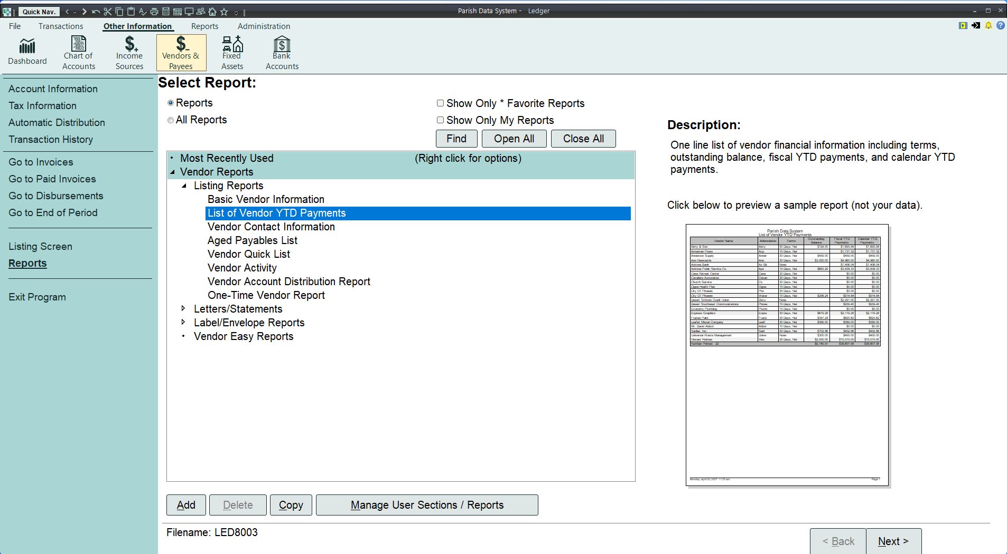

- Click: Next, Next, Next, Next, Simple Selection - Never Saved, Additional Selections tab, Click here to add new condition
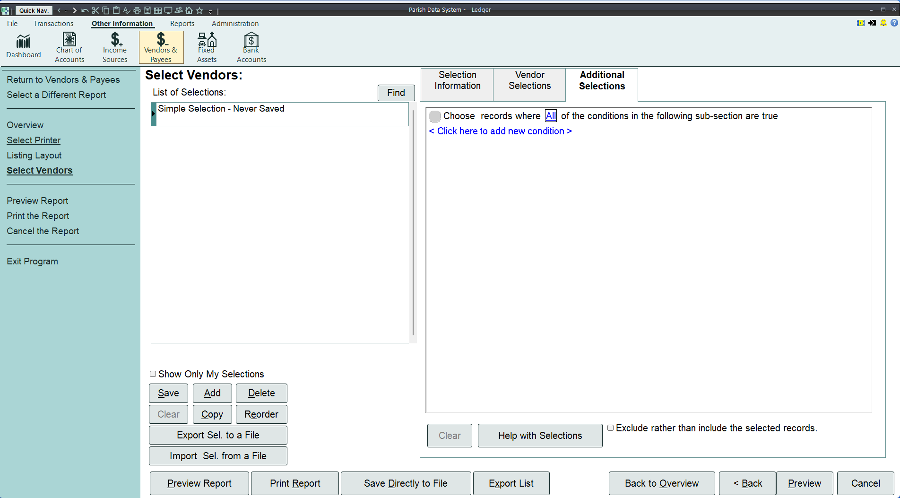

- Click: Ven Totals, Calendar YTD

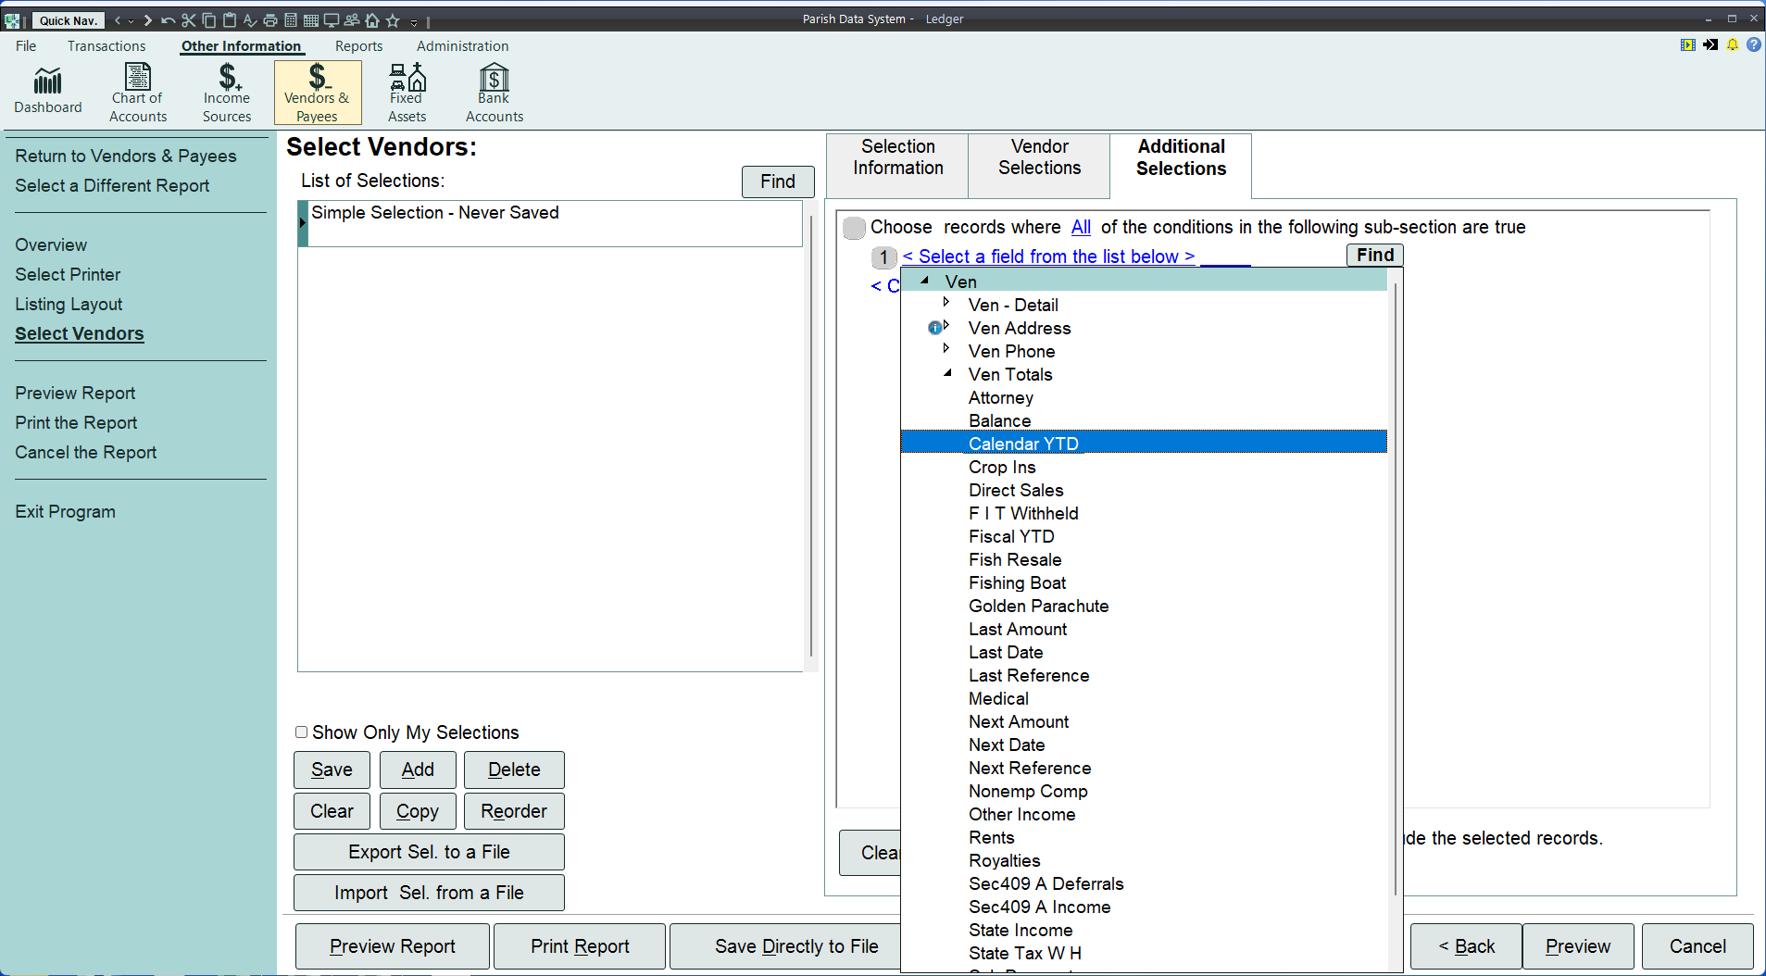

- Click: is equal to

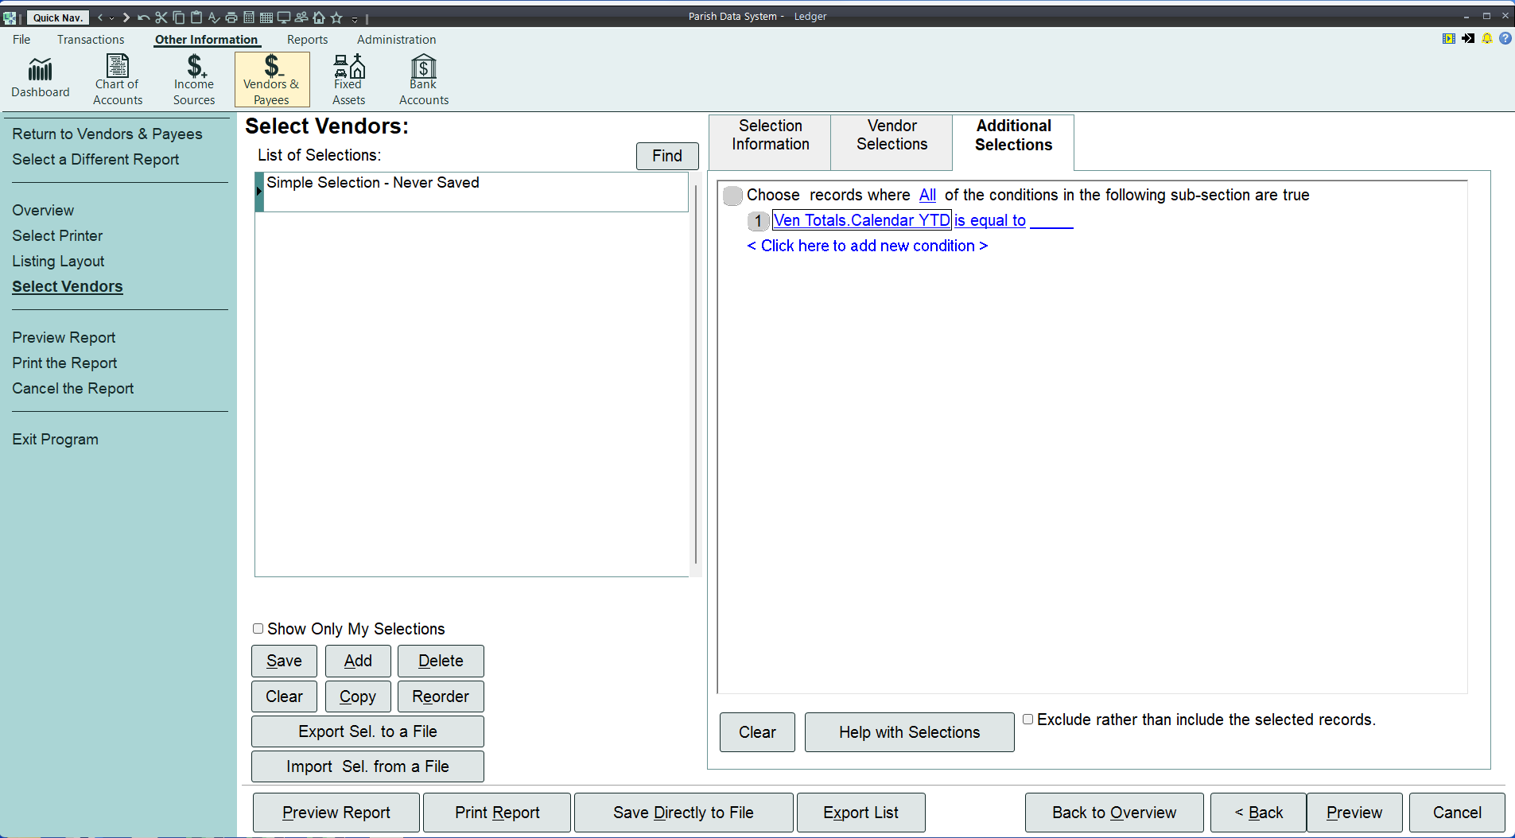

- Click: is greater than or equal to

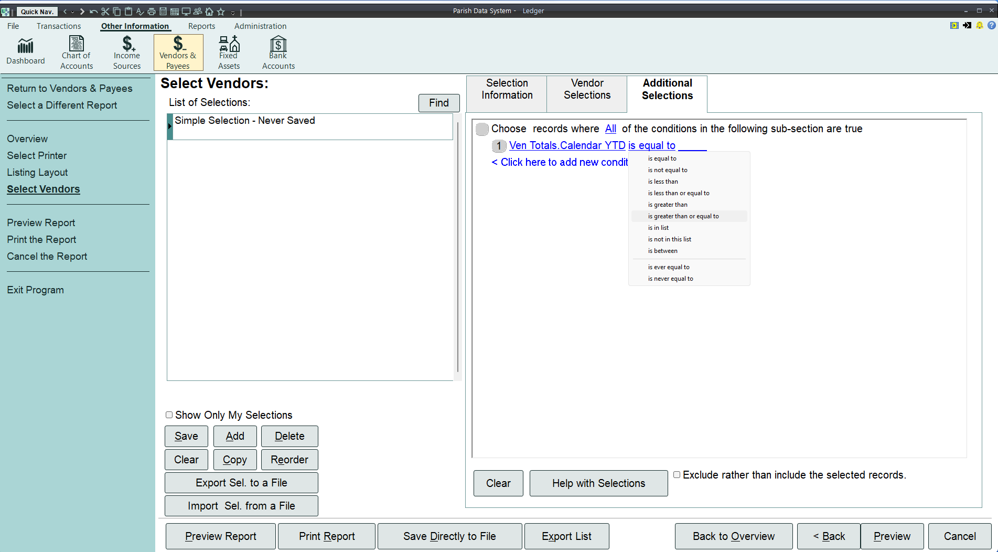

- Click on the space with the blue underline located to the right of the “to”

- Type 600.00

- Click: Preview, Print, Ok, Close

- Examine the report and determine which vendors should receive 1099s. There are additional IRS guidelines that must be met in order for a vendor to qualify to receive a 1099 beyond the dollar amount threshold. The IRS Website with Instructions for Forms 1099-MISC and 1099-NEC (01/2024) is: https://www.irs.gov/instructions/i1099mec.

- Make sure that the name of your Parish or School, address information, and phone number are filled-in and accurate in the License Information by doing the following:

  - Click on File

  - Click on Setup

  - Click on License Information

  - Make any necessary changes or additions. Please note that there may be a license validation that evaluates if the combination of Licensee Name, Site Number, and Registration Code matches the ACS Technologies records. Making a change to the Licensee Name without an official change from the ACS Technologies Support team may cause an issue in your Ledger. If any desirable changes were made, click on Save. Click on Close.

- Review and update tax information for vendors:

  - Click on Other Information

  - Click on Vendors & Payees

  - Click on in the top bar to go to the first vendor record

  - Click on Tax Information on the left side of the screen

  - For each vendor:

    - Review the status of the “Vendor Receives a 1099” checkbox and mark or unmark it if needed based on whether or not the vendor should receive a 1099 for the previous calendar year.

    - Enter the Taxpayer ID Number (TIN) for the vendor if this vendor should receive a 1099 (If there is a TIN for a vendor that should not receive a 1099 for the previous calendar year, it can remain there.)

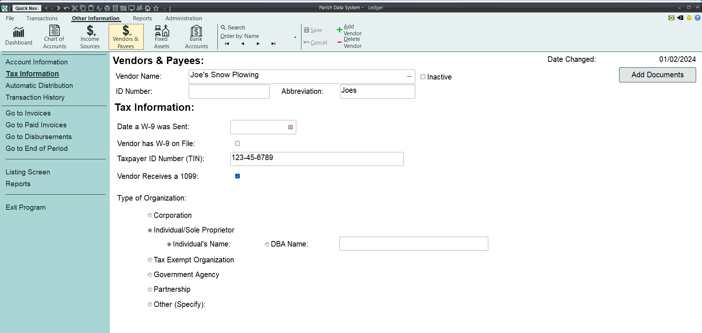

    - If a vendor should receive a 1099, click on Account Information on the left side of the screen. Then make sure that the information for the vendor is complete and accurate. If the Calendar YTD total needs to be manually reduced to exclude payments that do not meet the criteria for a 1099, you can click on the Alter Totals button toward the lower right corner of the screen, enter the appropriate total value in the Current Total box that is located 2 lines below the Calendar YTD Payments heading, click on Save, and click on Close. Click on Tax Information on the left side of the screen.

    - Click on in the top bar to go to the next vendor record and repeat these steps for the next vendor

- Complete the 1099s. Per IRS Instructions, Form 1099-NEC can be filed using either paper forms from the IRS or electronic filing. However, starting tax year 2023 (submission in 2024), the IRS requires E-filing for 10 or more returns, including 1099 forms, W-2 forms, 1095 forms, etc. Also starting with tax year 2023, the evaluation is based on the aggregate total count against the 10 or more forms threshold. Electronic filing may be performed directly with the IRS for free or through Ledger for a fee. Keep copies of any paper forms submitted and print and keep copies of any electronically filed forms.

  - Electronic filing directly with the IRS:
    - Form 1099-NEC can be filed electronically at no cost through the IRS’s newly released Information Returns Intake System (IRIS). The IRS has provided an instruction video on use of the IRIS system and a general user guide. This free service is available to filers of any size.
      - Information Returns Intake System (IRIS): https://www.irs.gov/filing/e-file-forms-1099-with-iris
      - Instruction Video: https://www.irsvideos.gov/Business/Resources/HowtoUsetheInformationReturnsPortal
      - IRIS Taxpayer Portal General User Guide: https://www.irs.gov/pub/irs-pdf/p5717.pdf

  - Instructions from ACS Technologies for submitting 1099s through Ledger are available here: https://help.acst.com/en/pds/ledger-payroll/ledgerpayroll-user-guide/end-of-period/tax-e-file/electronically-file-your-1099s.

- After you have completed the 1099s, you may close the month of December (unless you have an unrelated specific reason to keep it open).

